**HOW TO DAY TRADE FOR A LIVING**

Profits can come with practice, the right tools and software, and proper ongoing education.

**Rule1:** Day trading is not a strategy to get rich quickly.

**Rule2:** Day trading is not easy. It is a serious business, and you should treat it as such.

a) You can succeed in Day Trading only if you handle it as a serious intellectual pursuit.

b) Emotional trading is the number one reason traders fail.

c) Practice self-discipline and defensive money management.

d) You must look within yourself, discard your illusions, and change your old ways of being,

1. Stock Selection
2. Entry
3. Exit/Stop loss
4. Risk Management

After the market opens, the Stock in Play will trade heavily in the first five minutes. If the Stock in Play has gapped up, some individual shareholders, hedge funds or investment banks may want to as soon as possible sell their shares for a profit, before the price drops. At the same time, some investors wanting to take positions in the stock want to buy as soon as possible before the price goes even higher. Therefore, in the first five minutes, an unknown heavy trading is happening between the overnight shareholders and the new investors. Scalpers usually ride the momentum right at the Open. After volatility decreases around ten to fifteen minutes into the Open, the stock will move toward or away from the VWAP. This is a test to see if there is a large investment bank waiting to buy or sell. If there is a large institutional trader aiming to buy a significant position, the stock will pop over the VWAP and move even higher. This is a good opportunity for us day traders to go long.

**Ch3: Risk and Account Management**

1. Risk Management:-

a) Am I trading the right stock?

Avoid stocks heavily traded by computers and institutional traders, small relative trading volume, and penny stocks.

b) What share size should I take?

It depends on trading amount and no.of shares and your daily earn goal.

c) What is my stop loss?

Maximum risk should on any trade is 2% of their account. Determine your maximum risk for trade, estimate your maximum risk per share and divide max risk for trade/max risk per share.

1. Success and failure are based on how traders behave and how they control their emotions.
2. Practice self discipline.
3. For every trade, you must ask yourself some questions:
4. Does this fit into my trading personality and my risk tolerance?
5. What strategy will this fit into?
6. If this trade goes the wrong way, where is my stop?
7. How much money am I risking in the trade, and what is the reward potential?
8. Be in touch with the results of your decisions and constantly be reviewing your performance:
9. Are you trading profitably?
10. Have you had five wins in a row or have you had five losses in a row?
11. If you are on a losing streak, will you be in touch with your own emotions and maintain your composure, or will you let your judgment be impaired?

**Ch-4: How to find stocks for trade**

Stocks in Play:

1. A stock with fresh news
2. A stock that is up or down more than 2% before the market open
3. A stock that has unusual pre-market trading activity
4. A stock that develops important intraday levels

Day trading works on the stocks that have ***high relative volume***. Don’t look for ***high total volume***;look for what’s above average for that specific stock. If trading volume is not higher than normal, it means that the trading is being dominated by institutional traders and high frequency trading computers. Stay away from it.

The most important characteristic of high relative volume stocks is that these stocks trade independent of what their sector and overall market are doing.

**RULE-7:** Retail traders trade only stocks in play, high relative volume stocks that have fundamental catalysts and are being traded regardless of the overall market.

We need high relative volume, but how much volume is enough. Don’t trade with average daily volume. You need certain liquidity in the stock to be able to get in and out of the stock without difficulty.

**What makes a stock a Stock in play?**

Usually it is the release of fundamental news about the stock either the day before or during the same trading day. Important news or events for companies acts as fundamental catalysts for their price action.

Fundamental catalysts for stocks make suitable for day trading:

1. Earning Reports 2. Earnings warnings/Pre-announcements 3. Earnings Surprises 4. FDA approvals/disapprovals 5. Mergers/Acquisitions

6. Alliances/partnerships/major product releases 7. Major contract wins/Losses

8. Restructurings/Layoffs/Management changes 9. Stock splits/buy backs/debt offerings

Check the news on all stocks up or down more than 2% pre-market and short-list my gapers watch list. Stocks in play the day before are often still in play for a few days later. Stocks for retail trading are three classes.

**Float and Market Cap**

*Float means the number of shares available for trading*. The highest number of shares available for trading is considered as ‘mega cap’ stock.

**Stock in play can be found in two ways:**

1. Pre-market morning watch list 2. Real time intraday scans

**Pre-market gapers:**

**Real Time Intraday Scans**

You need to find the stocks that are in play by day traders, stocks in play. A stock in play is a stock that offers excellent risk/reward opportunities 1:2 or 1:5.

1. We need high relative volume stocks.
2. a) Pre-market morning watch list

Scan every morning the stocks based on the criteria

1. Stocks that in the pre-market gapped up or down at least 2%
2. Stocks that have traded at least 50,000 shares in the pre-market
3. Stocks that have an average daily volume of over 5,00,000 shares
4. Stocks that have Average True Range of at least 50 cents (how large of a range a stock has on average every day)
5. There is a fundamental catalyst for the stock
6. As a rule, I do not trade stocks with an enormous short interest higher than 30% (the short interest is the quantity of stock shares that investors or traders have sold short but not yet covered or closed out)

b) Real time intraday scans

1. Have gapped up or down at least $1
2. Have ATR of more than 50 cents
3. Have average relative volume of at least 1.5 (the stock is trading at 1.5 times its normal volume)
4. Have average daily trading volume of at least 500,000 shares

**Ch-5: Tools**

1. Indicators on charts.
2. Price action in the form of candlesticks
3. Volume of shares being traded
4. 9 Exponential Moving Average (9 EMA)
5. 20 Exponential Moving Average (20 EMA)
6. 50 Simple Moving Average (50 SMA)
7. 200 Simple Moving Average (200 SMA)
8. Volume Weighted Average Price (VWAP)
9. Previous day’s closing price
10. Daily levels of support and resistance
11. Use hot keys to chart timings and to place orders.

**Ch-6: Candlesticks**

1. Indicators on charts.

**Ch-7: Most Important Day Trading Strategies**

Some strategies based on three elements:

1. Price Action 2. Technical Indicators 3. Candlesticks and Chart patterns

It is important to learn and practice all three elements at the same time.

There are nine best strategies, simple in theory but difficult to master and require plenty of practice. Prefer is 5-minute charts, but also simultaneously monitor 1-minute charts.

**Trade management and position sizing**

**Strategy 1: ABCD Pattern**

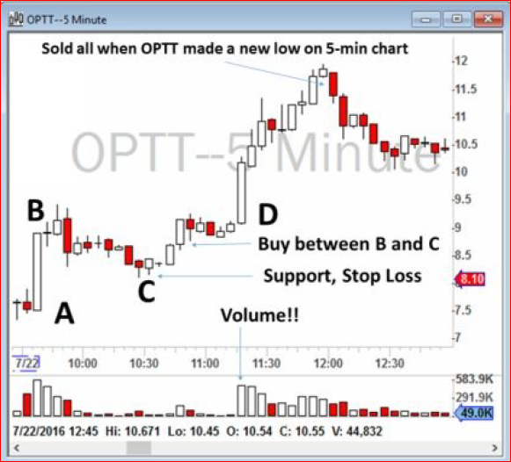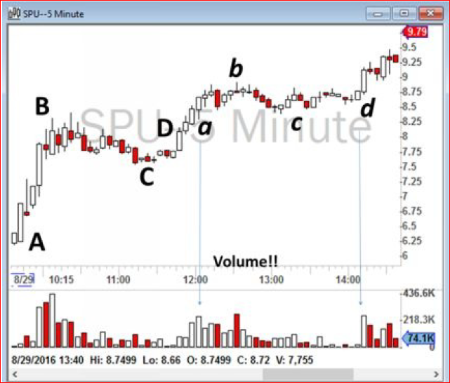

**Strategy 2: Open Range Breakout**

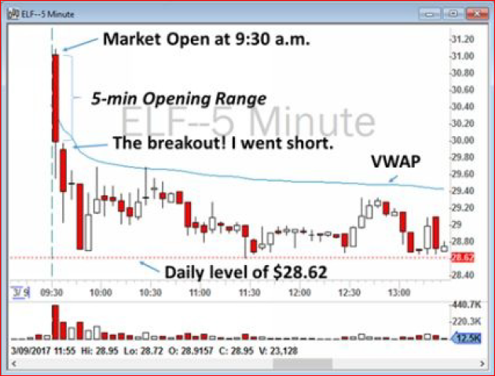 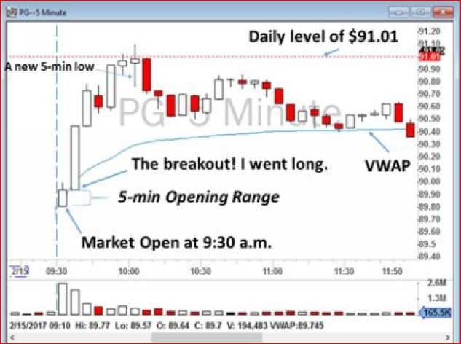

A stock at a specific time after the market opens. Trades are taken in the same direction at which the price moves out of this range. 15 minutes and 30 minutes are the most popular marked Ranges for day trading the Opening Range Breakouts. This strategy signals an entry point, but does not determine the profit target. You should define the best profit target based on the other technical levels.

Strategy tends to work best with mid to large cap stocks, which do not show wild price swings intraday. I do not recommend trading this strategy with low float stocks that have gapped up or down. Ideally, the stock should trade within a range which is smaller than the Average True Range of the stock (ATR). The upper and lower boundaries of the range can be identified by the high and low of the 5-, 15-, 30- or 60- minute candlesticks.

**Summarize my Opening Range Breakout Strategy:**

* 1. After I build my watchlist in the morning, I closely monitor the shortlisted stocks in the first five minutes. I identify their opening range and their price action. How many shares are being traded? Is the stock jumping up and down or does it have a directional upward or downward movement? Is it high volume with large orders only, or are there many orders going through? I prefer stocks that have high volume, but also with numerous different orders being traded. A stock that has traded 1 million shares, but those shares were only ten orders of 100,000 shares each, is not a liquid stock to trade. Volume alone does not show the liquidity; the number of orders being sent to the Exchange is as important.
  2. The opening range must be significantly smaller than the stock’s Average True Range (ATR). I have ATR as a column in my Trade Ideas scanner.
  3. After the close of the first five minutes of trading, the stock may continue to be traded in that opening range in the next five minutes. But, if I see the stock is breaking the opening range, I enter the trade according to the direction of the breakout: long for an upward breakout and short for a downward move.
  4. My stop loss is a close below VWAP for the long positions and a break above VWAP for the short positions.
  5. My profit target is the next important technical level, such as: (1) important intraday daily levels that I identify in the pre-market, (2) moving averages on a daily chart, and/or (3) previous day close.
  6. If there was no obvious technical level for the exit and profit target, I exit when a stock shows signs of weakness (if I am long) or strength (if I am short). For example, if the price makes a new 5-minute low, that means weakness and I consider selling my position if I am long. If I am short and the stock makes a new 5-minute high, then it could be a sign of strength and I consider covering my short position.

**Strategy 3: Previous Day Range Breakout**

Price moving above yesterday's High implies increasing demand. Similarly when price moves below Yesterday's Low reflects the increasing supply.  
Day traders often use this in combination with other day strategies to increase the odds.

Yesterday's High and Low values are used when defining the Previous Day Range (PRB). Trades are initiated in the same direction at which the price breaks out of the Previous Day's range.

**Strategy 4: Pivot Support & Resistance Crossovers**

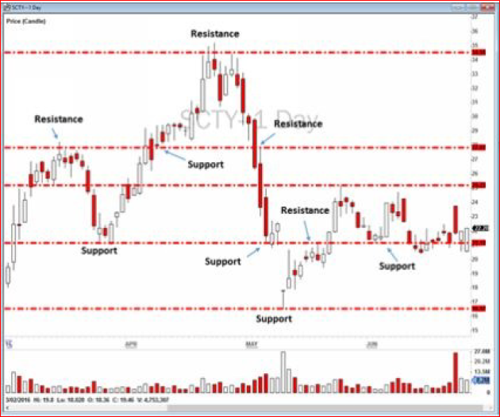

Support and Resistance levels are based on Classical Pivot Formula works like a magnet. You will be surprised to watch how intraday price reacts at these predefined levels. The levels are based on Yesterday's High, Low and Close. Price moving above or below these predefined levels signifies strength or weakness.​

**Strategy 5: Bull Flag Momentum**

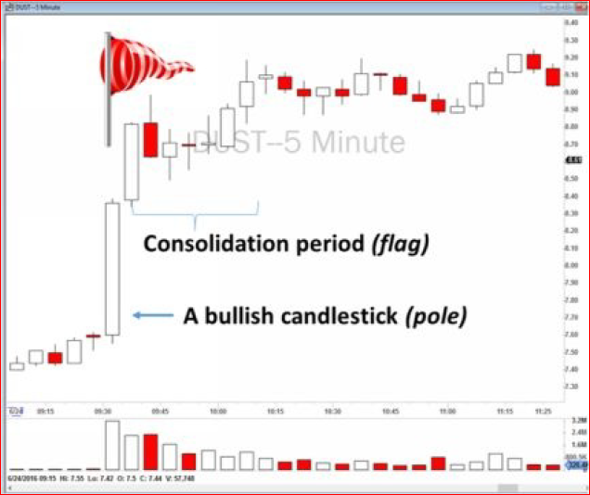 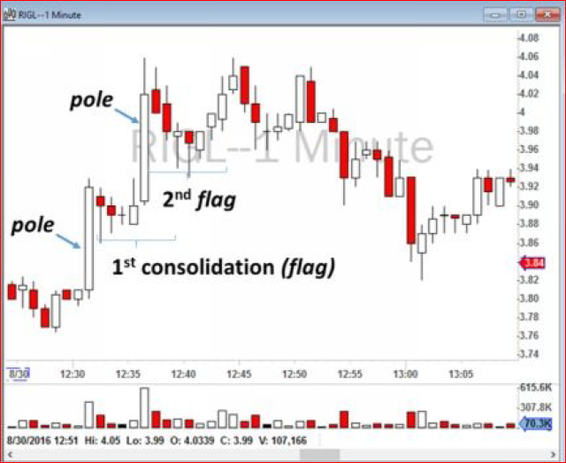

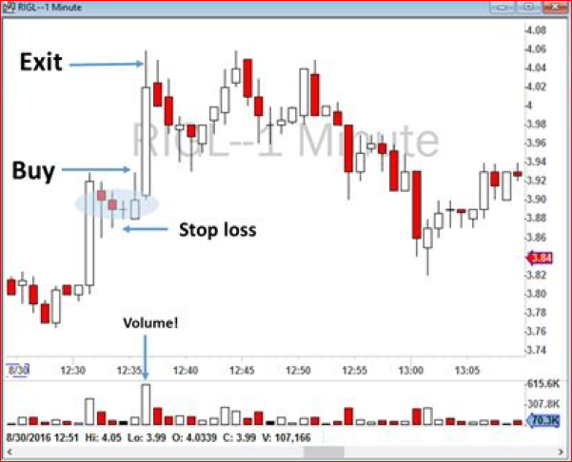 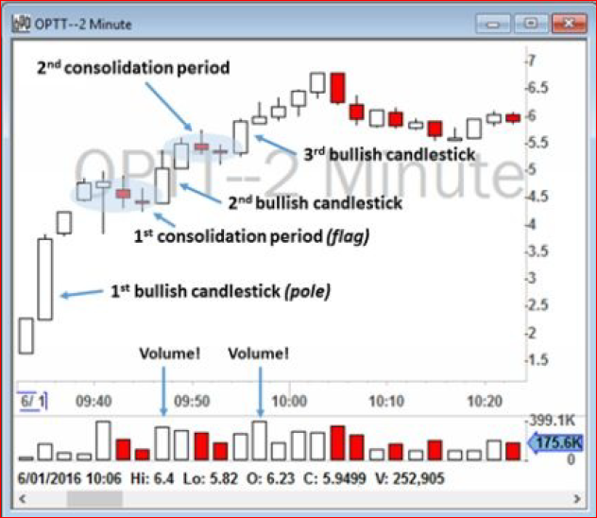

**Strategy 6: Moving Average Trend Trading**

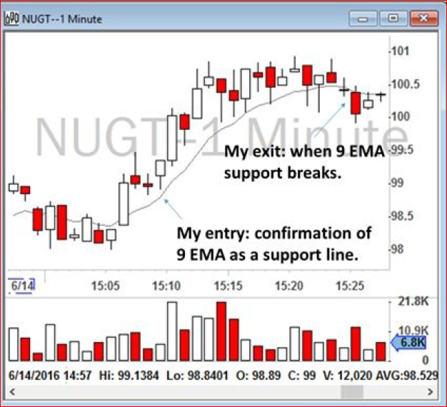 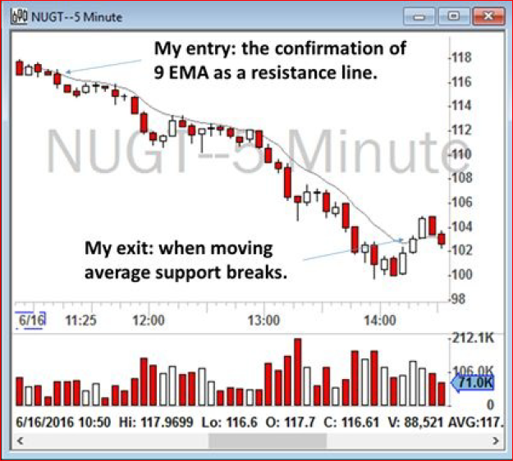

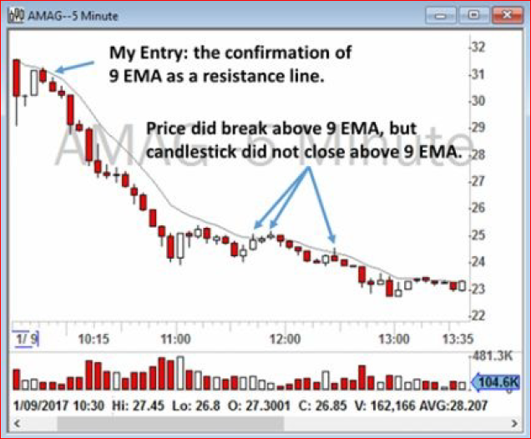 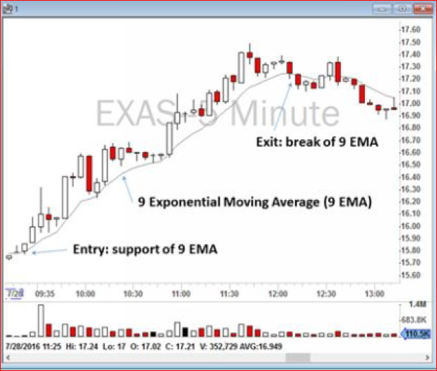

Use 9 EMA and 20 EMA. In NUGT 1min chart at 15.06 p.m. formed a bull flag and consolidation period was happening on top of 9 EMA. 9 EMA was holding as the support.

In AMAG 5min chart 9EMA held as strong resistance. Trade a short sell with stop loss of the break of 9EMA. In three areas marked on the chart, the price broke the 9EMA and went slightly higher, but a 5min candlestick did not actually close above 9EMA. These false breakouts usually happen with low volume. Experienced traders wait for a 5min candlestick to ‘close’ above 9EMA before they get out. A sudden break of 9EMA with low volume may not be a good indicator of a trend coming to an end.

**Strategy 7: VWAP Trading**

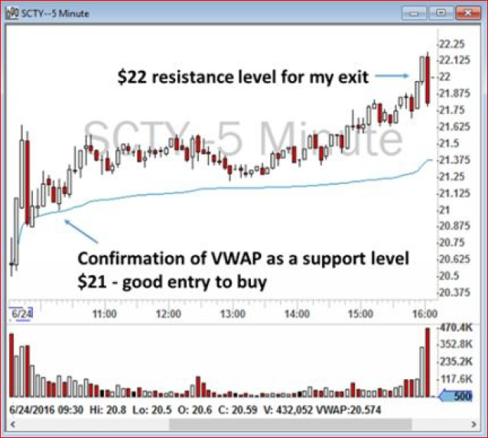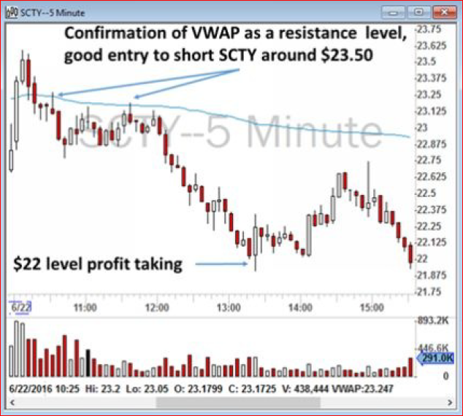

VWAP is an indicator of who is in control of the price action - the buyers or the sellers. When stock is traded above the VWAP, it means that the buyers are in overall control of the price and there is a buying demand on the stock. When a stock price breaks below the VWAP, it is safe to assume that the sellers are gaining control over the price action.

When a stock tries to break the VWAP but cannot, you can short the stock because you can safely assume that the other traders that are watching will also begin to short. A trading strategy based on VWAP is a simple and easy strategy to follow. I usually short stocks when traders try but fail to break the VWAP on 5-minute charts.

Summarize my trading strategy for VWAP trading:

1. When I make my watchlist for the day, I monitor the price action around VWAP at the Open. If a stock shows respect toward VWAP, then I wait until a confirmation of the VWAP break (for short selling) or VWAP support (for going long).
2. I usually buy as close as possible to VWAP to minimize my risk. My stop will be a break and a close 5-minute close below VWAP. For short selling, I short near VWAP with a stop loss of a close above the VWAP.
3. I keep the trade until I hit my profit target or until I reach a new support or resistance level.
4. I usually sell half-positions near the profit target or support or resistance level and move my stop up to my entry point or breakeven.

**Ch-8: Step-by-Step to a Successful Trade**

Strategies, based o

**Building a watchlist**

**Trading Plan (entry, exit and stop loss)**

**Execution**

**How Did I Do it?**

**Ch-9: Next Steps for Beginner Traders**